Assignment (20Marks)

Each question carries 4 Marks

1. Write a Python function that computes the harmonic sum of n. Accept n from user.

Harmonic Sum = (1/2) + (1/4) + (1/8) + (1/16) + ….. + (1/2 n )

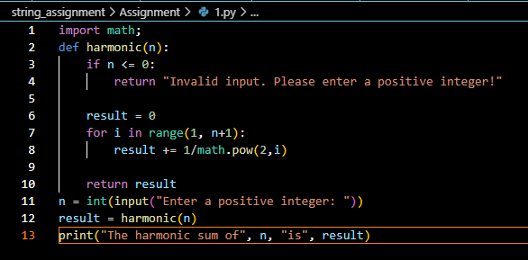

Output:

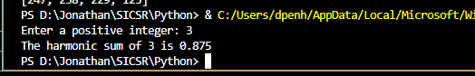

2. Write a python program to accept two 3X4 matrices and display their addition and

multiplication

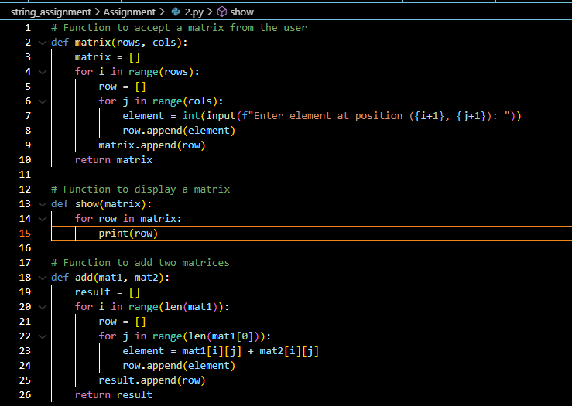

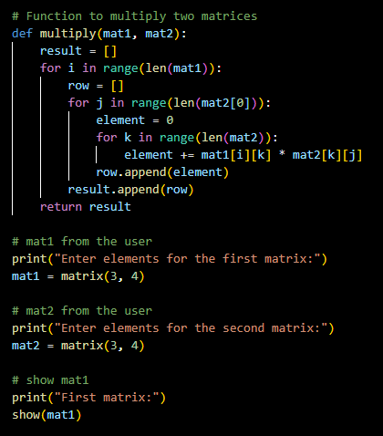

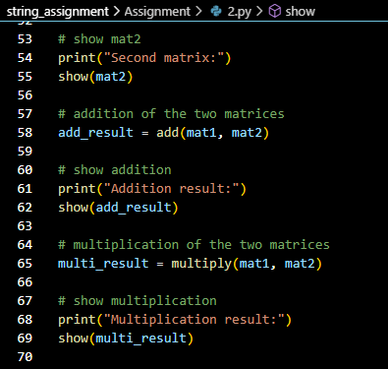

Output:

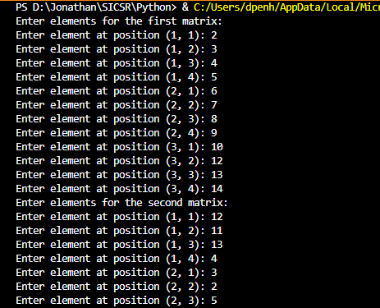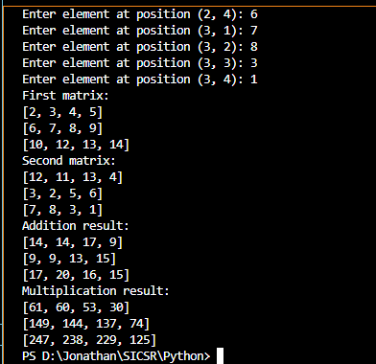

3. Write a Python program that performs the following operations on a given input string:

length, uppercase, lowercase, Count the number of vowels in the string, Count the

number of consonants in the string, Reverse the string, print total number of words in the

string, Capitalizes the first letter of each word in the string

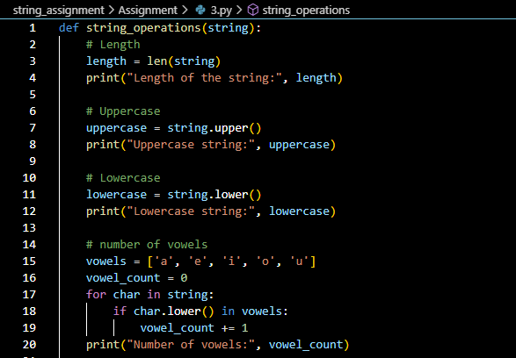

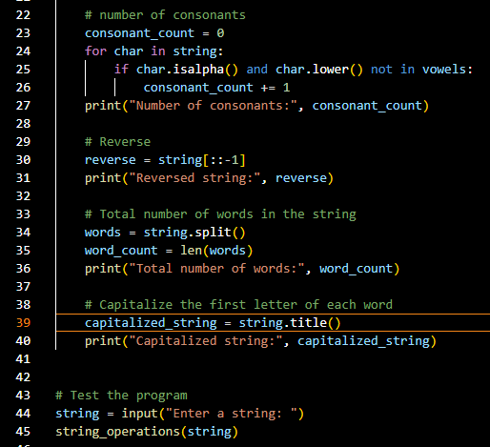

Output:

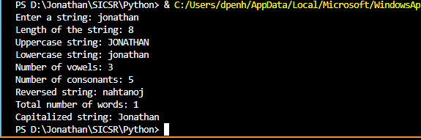

4. Write a python program with a function for given a simple list of objects like string or

integers as a parameter, checks whether there are duplicate elements in the list and return

True of False accordingly. The input list should not be changed.

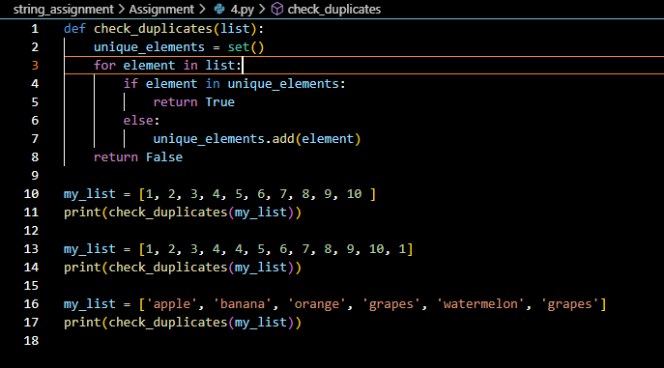

Output:

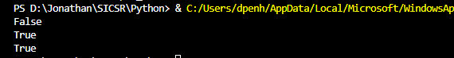

5. Write a python program to create a function called collatz() which reads as parameter

named number. If the number is even it should print and return number //2 and if the

number is odd then it should print and return 3\*number+1. The function should keep

calling on that number until the function returns a value 1.

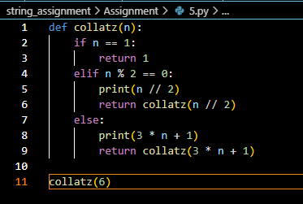

Output:

